**3. 图神经网络能帮助逻辑推理吗？**

标题：Can Graph Neural Networks Help Logic Reasoning?  
状态：Preprint. Under review.

链接：https://arxiv.org/pdf/1906.02111.pdf

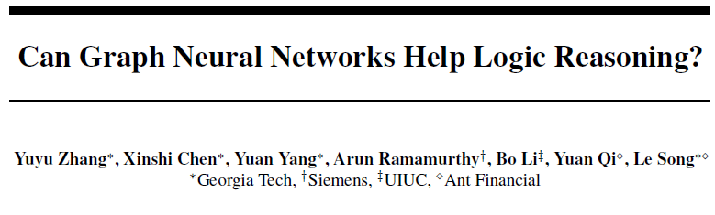

Effectively combining logic reasoning and probabilistic inference has been a longstanding goal of machine learning: the former has the ability to generalize with small training data, while the latter provides a principled framework for dealing with noisy data. However, existing methods for combining the best of both worlds are typically computationally intensive. In this paper, we focus on

【Idea】MLN+GNNs= ExpressGNN 结合l. r. and p. i.

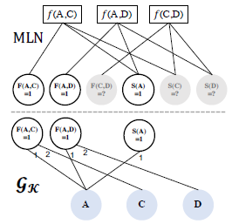 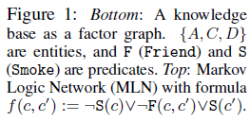

Markov Logic Networks (MLN) and explore the use of

graph neural networks (GNNs) for representing probabilistic logic inference.

It is revealed from our analysis that the representation power of GNN alone is not enough for such a task. We instead propose a more expressive variant, called

ExpressGNN, which can perform effective probabilistic logic inference while being able to scale to a large number of entities.

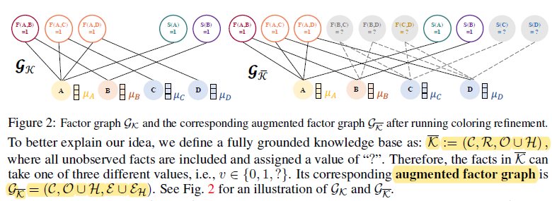

主要工作：1）如何将GCN的结果（向量）嵌入 MLN; 2)如何简化 向量。

We demonstrate by several benchmark datasets that ExpressGNN has the potential to advance probabilistic logic reasoning to the next stage.